Indicator calculation definition – LAND USE MAP

Indicator name | Land use map
Short description (max. 3 lines) | Land use pattern of the main land use types with a spatial resolution of 1 km2
Contact person and organization | Peter Verburg (WU) 485208

Indicator data type
Quantitative (please fill in table below)
Units | Discrete classes
Valid range | 10 classes
Qualitative or ordinal

Legend (for map display)
Name | Value or range | Colour indication (RGB)
0 | Built-up area | (219/0/0)
1 | Arable land (non-irrigated) | (254/250/194)
2 | Pasture | (163/222/133)
3 | (semi-) Natural vegetation | (114/137/68)
4 | Inland wetlands | (173/164/254)
5 | Glaciers, Snow, Sands and sparsely vegetated areas | (160/160/160)
6 | Irrigated arable land | (254/172/0)
7 | Recently abandoned farmland | (205/205/102)
8 | Permanent crops | (207/152/107)
9 | Forest | (1/99/0)

Level of map presentation (e.g. 1x1km gird, nuts2, HARM, etc)
ONLY at 1x1 km grid

Description of causality in calculation method (max. 10 lines)
Direct output of the Dyna-CLUE land use allocation model. This model simulates competition among land uses for the available land resources based on the demand at national level (output GTAP/IMAGE calculations) and the local options set by the biophysical and socio-economic environment. The total area of agricultural and urban land uses is constrained by sectoral calculations at the national level while the succession of natural vegetation is determined by the local conditions. A wide range of location factors, spatial policies, neighborhood interactions and specific conversion trajectories are included as determinants of the simulated land use changes

Calculation input parameters (name, source and units. Please add whether this comes from Clue, Image, Gtap ,own datasource or other indicator)
Name | Quantity | Source | Description
Land cover | Dyna-Clue classes | Clue AsciiGrid grid 1x1 km | Full legend CLUE map (classified to 17 landuse classes)

Technical implementation of calculation method (Incl aggregation method)
Reclassify the maps for each year of display following the scheme presented below (RGB colour codes between brackets). This reclassified the 17 classes into 10 classes for visualization.
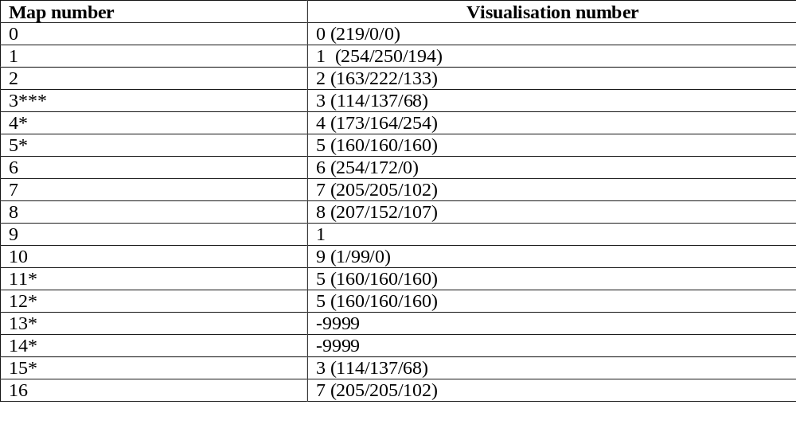

Use the following legend with ‘short’ land use type names:
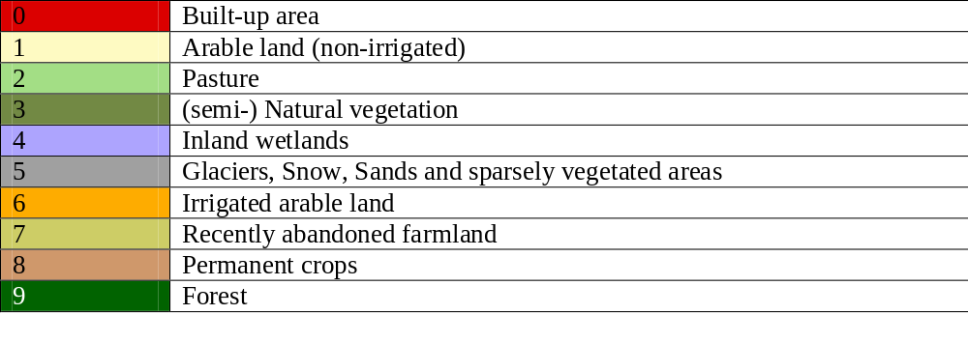

Note: THIS indicator is ONLY available at grid level (1x1 km). NO aggregation scheme available/needed

